Design Thinking Project Report on

**SMART BUS TICKET BOOKING SYSTEM**

Submitted to

The Department of Computer Science and Engineering

Bachelor of Technology

in

Computer Science and Engineering

(2021 – 2025)

L.THIRUPATHI 22R15A6705

S.RATHNAKAR 22R15A6707 B.SIDDU 22R15A6702 K.NIRANJAN 22R15A6704

Under the Guidance of

Mrs. K. Laxmi

Mrs. K. Gayathri

Department of Computer Science and Engineering

Accredited by NBA

**Geethanjali College of Engineering and Technology (UGC Autonomous)**

(Affiliated to J.N.T.U.H, Approved by AICTE, New Delhi)

Cheeryal (V), Keesara (M), Medchal.Dist.-501 301.

**August-2023**

**ABSTRACT**

A smart bus ticket booking system is a digital platform that allows passengers to book and purchase bus tickets online, using a mobile app, or a website. It provides a convenient and efficient way for passengers to book their bus rides and eliminates the need for paper tickets and cash transactions. The smart bus ticket booking system also provides real-time information about bus schedules, routes, and delays, and allows passengers to track their bus in real-time. This system benefits passengers by providing a seamless and convenient experience, reducing wait times, and optimizing travel planning. It also benefits bus operators and transportation authorities by reducing costs and increasing efficiency. The implementation of a smart bus ticket booking system involves several steps, including a feasibility study, developing a business case, choosing appropriate technology, developing software and hardware, testing the system, implementing the system, and monitoring and evaluating the system's performance over time.

**INDEX**

**Abstract** I

**1. Introduction** 1

1.1 Object 1

1.2 Scope 1

1.3 Existing System 2

1.4 Proposed System 3

**2. System Analysis** 4

2.1 Functional requirement specification 4

2.2 Performance requirements 4

2.3 Software requirements 5

2.4 Hardware requirements 5

**3. System design** 6

3.1 Architectural design 6

3.2 Modules 7

**4. System implementation** 8

4.1 Algorithms 8

**5. Output Screens** 14

**6. Future scope** 20

**7. Conclusion** 22

**8. References** 22

**List of Figures**

**S.no Fig no Title of Figure Page no**

1. 3.1Architectural Design of Project 6
2. 5.1 Home page 14
3. 5.2 Passenger’s Sign Up page 15

4 5.3 Passenger’s Login page 15

5 5.4 Login Book Bus page 16 6 5.5 Payment Details page 17 7 5.6 Bus Operator’s Login page 17 8 5.7 Bus Operators Dashboard 18 9 5.8 QR Code validation page 18

1. **INTRODUCTION**

The Smart Bus Ticket Booking System aims to revolutionize the way customers experience public transportation by providing a user-friendly platform for booking bus tickets seamlessly. This modern-age technology solution connects passengers with available bus routes, book online tickets, secure payment methods, enhancing the overall commuting experience. This smart bus ticket booking system will lift the online bus ticket system to a new level by introducing QR code for the purpose of bus ticket and safe transactions.

**Objectives**

To create a user-friendly website that allows customers to effortlessly book bus tickets with minimal steps and provide real-time information about available buses, bus routes, and to facilitate efficient coordination between passengers and conductors ensuring smooth and reliable transportation services.

**Scope**

The Smart Bus Ticket Booking System is an innovative application that aims to streamline and enhance the process of bus ticket booking for passengers. This system will serve as a user-friendly platform accessible to both passengers and bus operators.

This platform offers convenient ticket booking options, and secure payment methods. The system aims to revolutionize the bus transportation experience for users, providing a seamless and efficient solution for booking bus tickets.

The passenger can book their bus tickets based on their desired locations, according to the location provided by the passengers and chooses the available buses to integrating QR Code for booking of bus tickets will give a smooth and seamless experience for passengers. The bus operator handles the bus route details and validates the passengers QR Code by scanning it. This platform ensures the security of information of both passengers and bus operators as well as bus information, payment system. This system will reduce the time for both passengers and bus operators for booking ticket and handling it. and it also removes the conflicts between the passengers and bus operators about change while ticket generation. This system provides a smooth and seamless experience for the passengers and bus operators and to ensure they will enjoy the journey happily!

**1.2 Existing Systems**

In the traditional bus ticket booking system, passengers get their bus tickets after onboarded in the bus the bus operator will goes to the passenger and ask for the details about the journey and generates a ticket. And passenger will have to hold the ticket through the journey. This leads to the conflicts between the both passengers and bus operators.

* The following are the drawbacks of the current existing systems:
* **Manual Ticket Booking:** The conductor will visit the passenger and asks for the journey details and generates a ticket. The passenger will maintain the ticket throught the journey.
* **Cash Transactions:** Ticket payments are primarily made in cash, which may not always be the most secure or convenient payment method for passengers will leads to conflict between the passenger and bus operator.
* **Limited Information:** Passengers may have limited access to information about bus routes, fares, leading to a less informed travel experience.
* **Limited Customer Support:** In case of changes in travel plans or cancellations, passengers may face difficulties in getting immediate customer support or refunds.
* **Lack of Integration:** The traditional system often lacks integration with other transportation services or additional amenities, limiting passengers' options and convenience.

Overall, the existing system presents various limitations that can hinder the overall travel experience for passengers and create inefficiencies in the ticket booking process. There is a need for a more streamlined and user-friendly system that provides real-time information, online accessibility, and secure payment options to enhance the bus ticket booking experience for passengers. The proposed Smart Bus Ticket Booking System aims to address these challenges and revolutionize the way bus tickets are booked and managed.

**1.3 Proposed System**

The proposed Smart Bus Ticket Booking System is an advanced online platform that aims to revolutionize the bus ticket booking process, providing passengers with a seamless and convenient experience. It leverages modern technologies to overcome the limitations of the existing system and offers a range of features to enhance the overall travel experience for passengers.

* Here are the key features and benefits of the proposed system:
* **Online Ticket Booking:** The proposed system allows passengers to book bus tickets online through a user-friendly web application. This eliminates the need for physical tickets and cash, providing convenience and time saving for passengers.
* **Secure Online Payments:** The system offers secure online payment options, allowing passengers to make ticket payments using various digital payment methods. This enhances the safety and convenience of the payment process.
* **Automatic Ticket Confirmation:** After booking, the passenger will prompt with a QR Code and that is the ticket. The bus operator then validates the QR Code.
* **Eco-Friendly and Paperless:** The proposed system promotes eco-friendliness by reducing paper usage through digital ticketing and online transactions.

The Proposed System aims to provide a modern, efficient, and user-friendly solution for passengers to book bus tickets, enhancing their travel experience. By embracing technology and innovation, this system streamlines the entire booking process, offers real-time information, and ensures the security and convenience of ticket booking for passengers and bus operators alike.

**2.SYSTEM ANALYSIS**

The System analysis for the Smart Bus Ticket Booking platform involves a comprehensive review of the project goals, breaking down the system into various modules, and specifying functional requirements and performance criteria.

**2.1 Functional Requirement Specification**

The Smart Bus Ticket Booking platform has been identified to consist of the following modules:

* User/Passenger Module
  + - Users can register and create accounts on the platform.
    - Passengers can search for the available buses based on from and to location.
    - Passengers can book the tickets based on the available buses and fair price.
* Bus Operator Module:
  + - Bus Operator can login to the platform using credentials given by admin.
    - Bus Operator can manage the bus routes, bus stops, and passengers.
    - Bus Operator must validate the QR Code/ticket of the passenger.
* Admin Module:
  + - The platform will have an admin who can manage user accounts, verify registrations, and handle system settings.
    - The administrator can oversee passenger’s info and bus operator info to maintain overall platform security.

**2.2 Performance Requirements**

Performance requirements for the Smart Bus Ticket Booking platform are crucial for ensuring a smooth and efficient user experience. Key performance criteria include:

**Response Time:** The system should respond to user interactions, such as route searches, bus selection, and payment processing, within milliseconds to ensure a smooth user experience.

**Payment Security:** The system's payment gateway must be secure and comply with industry standards to protect users' financial information from unauthorized access or fraud.

**Scalability:** The system must be able to scale efficiently to handle a large number of concurrent users during peak booking times, such as holidays or special events.

**Reliability:** The platform must be reliable, with minimal downtime or service disruptions, allowing people to book tickets at their convenience time.

**Data Processing Speed:** The system should process data quickly and efficiently, especially during peak booking times, to prevent delays in ticket confirmation and avoid overbooking.

**2.3 Software Requirements**

* The software requirements are:
* Operating System: Microsoft Windows XP.
* Front-End: HTML, CSS, and JavaScript.
* Back-End: JavaScript
* Database: MySQL.
* **Web-Server**: Node JS
* Framework: Express

**2.4 Hardware Requirements**

* Processor: Intel P-IV based system
* RAM: Min. 512 MB

**3.SYSTEM DESIGN**

System design for the Smart Bus Ticket Booking platform involves the detailed specification of the architecture, components, modules, data flow, and interactions between different parts of the system. It focuses on converting the requirements into a well-structured and efficient system that meets the users' needs.

**3.1 Architectural Design**

The architectural design of the Smart Bus Ticket Booking platform encompasses various components that work together to deliver a seamless user experience. The system architecture can be represented as follows:

The user/passenger, bus operator are the main actors in the system. The front-end components, developed using HTML, CSS, and JavaScript, provide a user-friendly interface for users to interact with the platform. The back-end components, built using Node.js, Express, and MySQL, handle the data processing, business logic, and communication with the database.

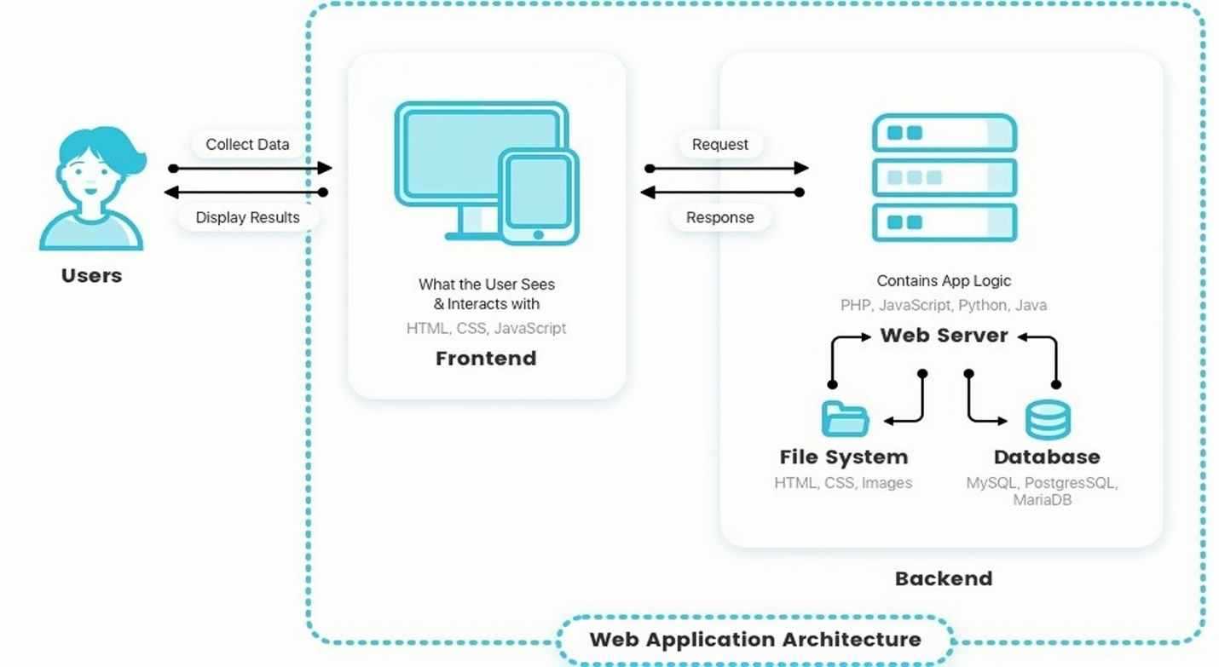

Fig 3.1 : Architectural Design of Project

**3.2 Modules**

**User/Passenger Module:**

* Passenger Registration: Passenger can register and create accounts on the platform.
* Available Buses: Passengers can browse available buses based on the from and to locations they select.
* Ticket Booking: Passengers can book tickets based on the details provided.

**Bus Operator Module:**

* Bus Operator Registration: Bus Operator can login with credentials provided by Admin.
* Ticket Validation: Bus Operator can be responsible to validate Passengers ticket.

The system design ensures that each module works cohesively, facilitating a smooth user experience and efficient platform for passengers to book bus tickets and for bus operators to manage their services effectively. The architecture and modules form the foundation for the development and implementation of the Smart Bus Ticket Booking platform. It focuses on converting the requirements into a well-structured and efficient system that meets the users' needs.

**4.SYSTEM IMPLEMENTATION**

The implementation stage of any project is a true display of the defining moments that make a project a success or a failure. The implementation stage is defined as the system or system modifications being installed and made operational in a production environment. The phase is initiated after the system has been tested and accepted by the user. This phase continues until the system is operating in production in accordance with the defined user requirements.

**4.1 Algorithms**

**Algorithm main page**

**{**

Enter Portal number of the website in the web browser (http://localhost:3000)

If (Passenger)

{

Goto Passenger();

}

Else if (Bus Operator)

{

Goto Conductor ();

}

Else

{

The rest of the viewers have the visibility of only the following Pages to more about the site

Home

Contact Us

Service

}

}

**// end of main page….**

**Algorithm Passenger**

{

**Algorithm Passenger Login Page**

{

If (Already registered then login)

{

1. Enter Username and password;
2. Click Login

}

Else

{

click Register to get registered.

}

}

**// Redirecting to Sign-up page**

**Algorithm Passenger Sign-up Page**

{

If (Sign-Up)

{

Fill registration form and submit;

After successful Signup page will redirect to next page;

}

}

**// Redirecting to Login Book bus**

**Algorithm Passenger’s Login Book Bus Page**

{

Enter From Location in Search Bar;

Enter TO Location in Search Bar;

// According to the from and to location the bus number, route, distance, fair price is displayed.

If (Button Find Buses Clicked)

{

The Bus number, Bus route, Distance, Fair price are generated from the database using Node.js server.

}

Else // (Clear Button)

{

The From and To Location gets Clear;

}

// After generating the details a select button is displayed on each result.

If (Button Select Clicked)

{

Redirects to Payment Details page.

}

**// Redirecting to Payment Details**

**// Based on the selected result the Payment Details are Displayed**

**Algorithm Payment Details**

{

If (Pay Now Button)

{

Payment Processing.

Payment Success.

QR Code will be generated.

Map will be Displayed.

}

Else

{

Redirect to Login Book Bus page.

}

}

// Profile Icon is displayed when page loads

**Algorithm Profile Page**

**{**

If (Profile Icon Clicked)

{

Passenger details are displayed.

Such as Name, ID, Mobile Number, Email.

And a LOGOUT Button.

If (Button LOGOUT Clicked)

{

Redirects to Passengers Login page.

}

}

}

**Algorithm Bus Operator**

{

**Algorithm Bus Operator Login Page**

{

If (Already have Credentials then login)

{

1. Enter Username and password;
2. Click Login

}

Else

{

Admin will send the details.

}

}

**// Redirecting Bus Operator Dashboard**

**Algorithm Bus Operator Dashboard**

{

Conductor id is displayed.

If (Select Bus Number)

{

According to Bus Number, Route Map will be Displayed.

}

// Validate QR Code button is displayed in Dashboard.

If (Button Validate QR Code clicked)

{

Redirects to QR Code Validation page.

}

Else

{

Redirects to Dashboard.

}

//**Algorithm QR Code Validation Page.**

{

Scanner will open upon loading the page

If (QR Code detected)

{

QR Reader stopped.

Details are displayed.

Such as Passenger Id,

Bus Number,

Date,

From and To Locations.

}

// To Validate the details the Validate button will appear upon QR Code Detection.

If (Validate Details Clicked)

{

If (Passengers B.no = = Conductor B.no && Passengers Date = = Current Date)

{

Ticket Validated

}

Else

{

Invalid Ticket!!

}

// Window will close Automatically and Redirects to Bus Operators Dashboard.

}

}

**5. OUTPUT SCREENS**

Output Screens of various functionalities in our application are shown over here along with the description.

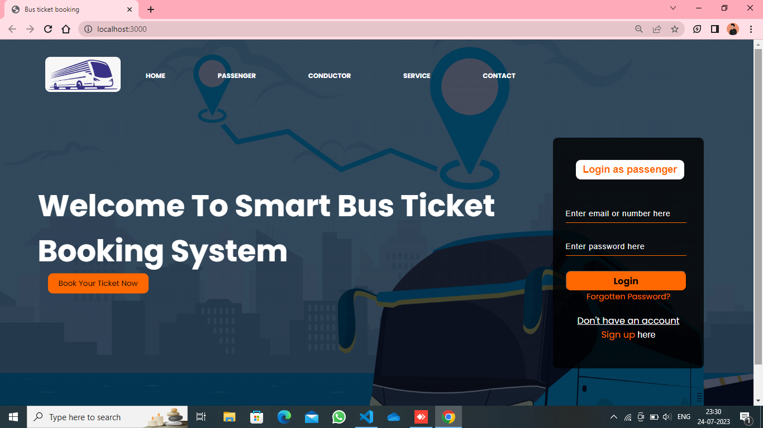

Fig 5.1 : Home page

This is the “Home page” of the Smart Bus Ticket Booking System. This main page of the website is accessed through the specified portal number in the web browser. This page mainly consists layout of our web-site. This page has got several tabs named as Home, Passenger, Conductor, Services, Contact Us. If we select any tags the further gets Display in the website.

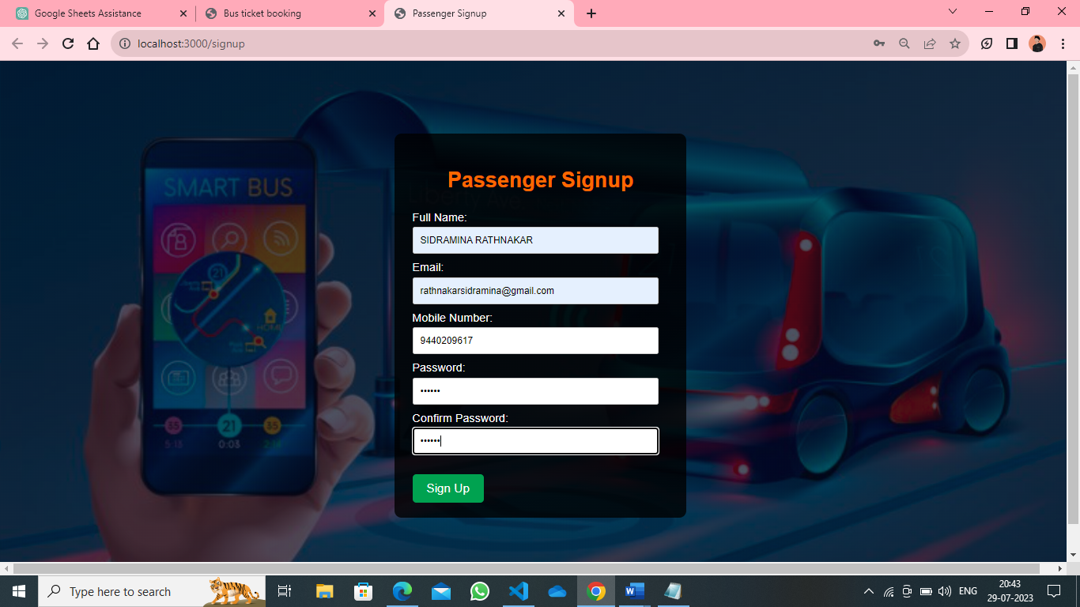

Fig 5.2 : Passenger’s Sign Up page

The "Passenger’s Sign Up” page is the next page if the user anchor is clicked on signup. The labels and text fields are displayed the user/passenger will fill the required details such as Full Name, Email, Mobile Number, Password. The password validation should be done and when the user/passenger clicks on signup button a Success message will be displayed and redirects to Login Page.

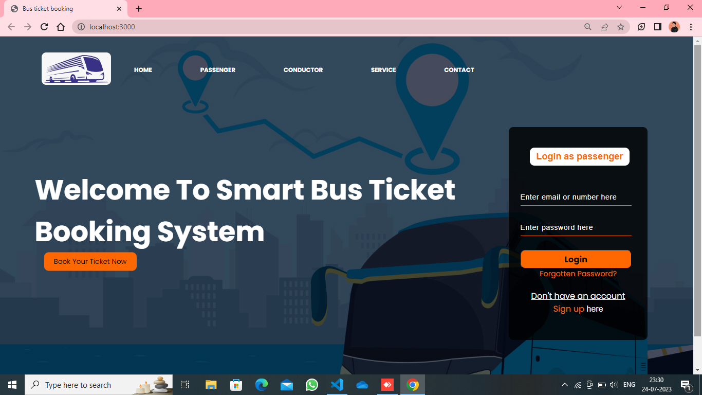

Fig 5.3 : Passenger’s Login Page

The “ Passenger’s Login page” is same as Home page. Now the registered user/passenger will enter the required credentials such as Mobile Number, Password to login. When the user/Passenger clicks on the Login Button the system validates the details, if the details are not valid an error message “Invalid Mobile Number or Password” message is displayed else Next Login Book Bus page is displayed.

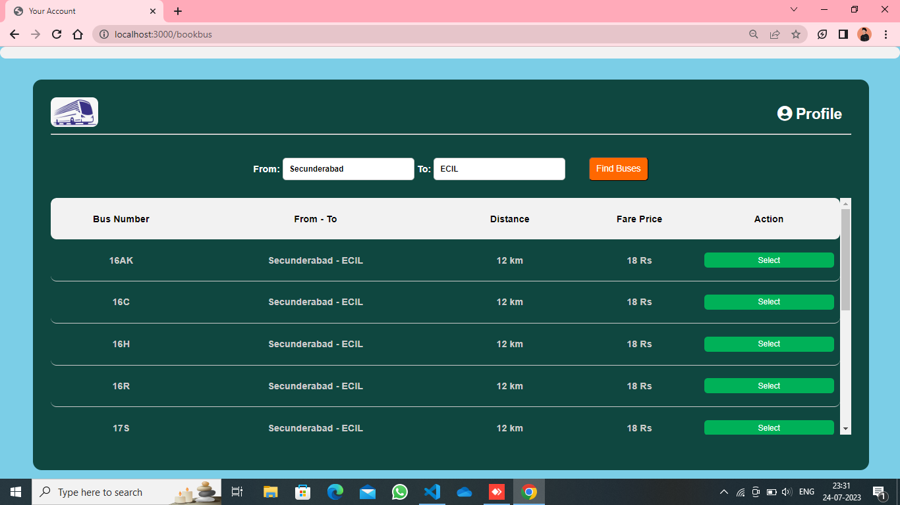

Fig 5.4 : Login Book Bus page

The “Login Book Bus page” serves as the interface for user/passenger to input their from and to locations and when the user/passenger clicks on the Find Buses button according to the details the available buses and route details, distance between them and fair price will be displayed with select button on each result. When the user/passenger chooses a bus and clicks on select button it redirects to the Payment Details page.

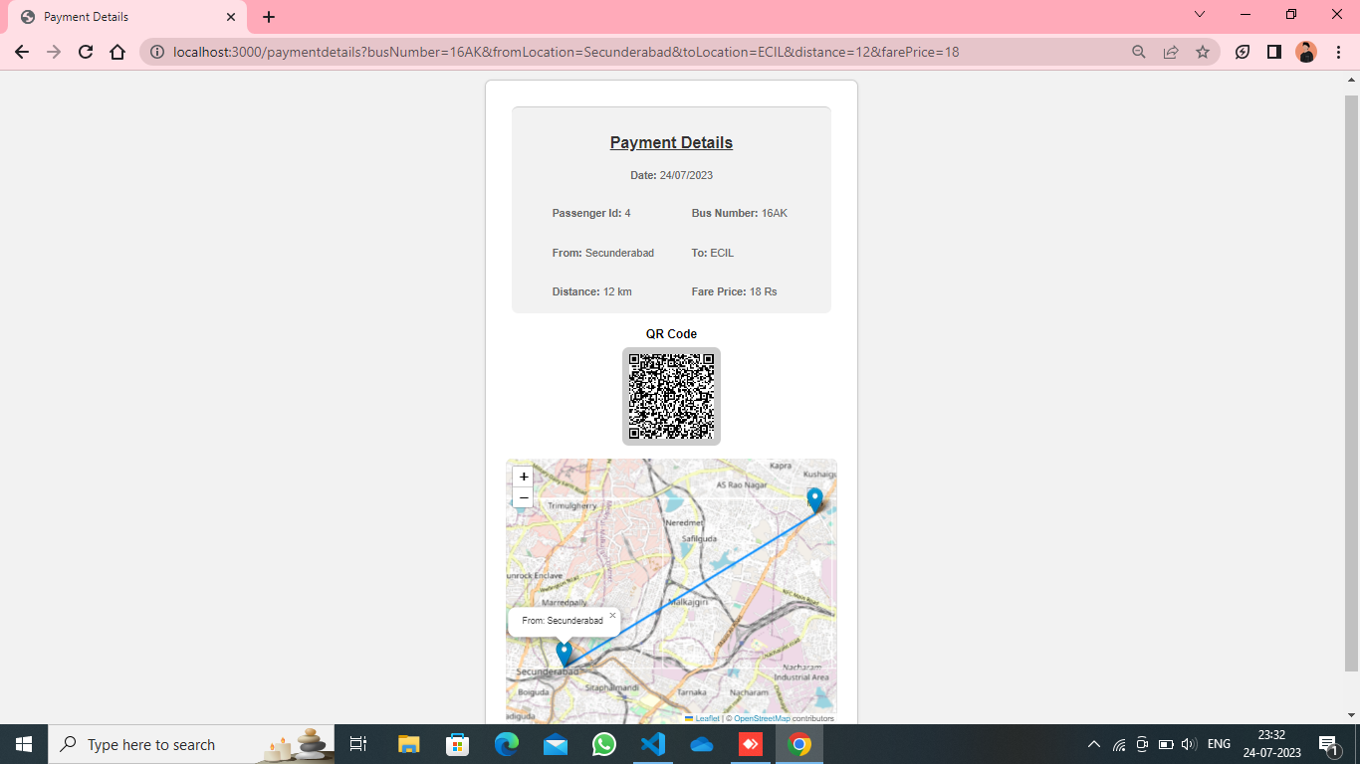 Fig 5.5 : Payment Details page

The “Payment Details” page contains the details such as passenger id, bus number, from and to locations, distance and fair price and a Pay Now button as well. When the button is clicked payment successful message will appears and then QR Code and map will be displayed. The QR Code is encoded with the Payment Details.

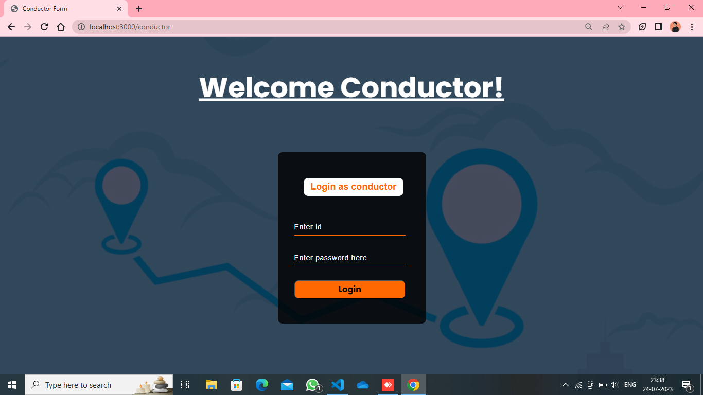

Fig 5.6 : Conductor’s page

In the “Conductor’s page” the conductor alias Bus Operator will login with the credentials given by the admin. The credentials are validated by the server if the credentials are not valid “Invalid Id or Password” message appears, else redirects to Bus Operators dashboard.

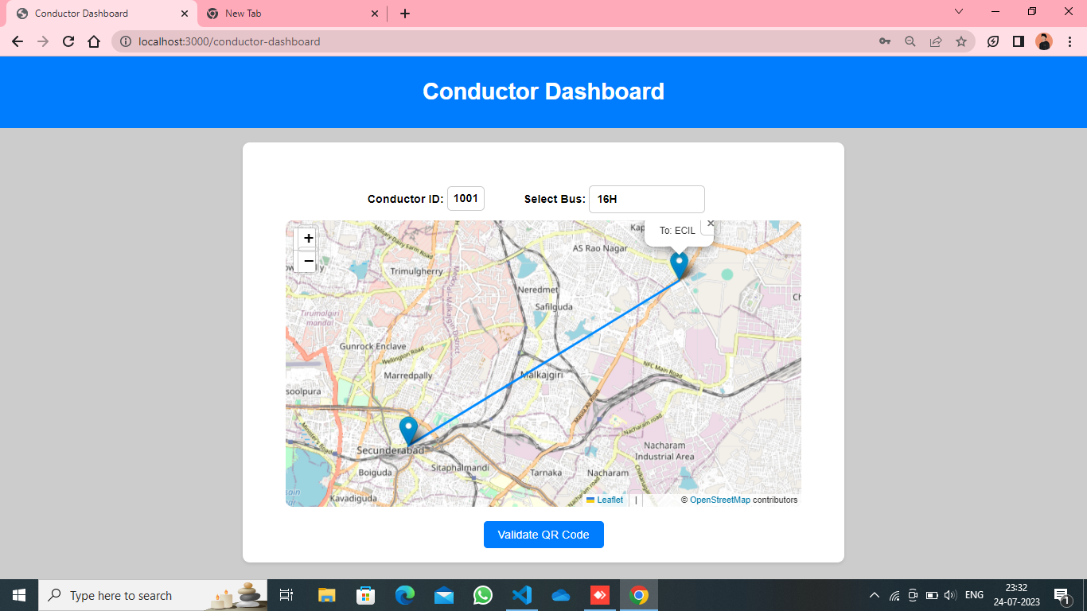

Fig 5.7 : Bus Operator’s Dashboard

When the “Bus Operator Dashboard” loads the conductor id automatically displayed and the Validate QR Code button. The bus operator has to select the bus number. Upon selecting the bus number, the route map is displayed shows the route of the bus. When the Validate QR Code button is clicked it redirects to QR Code validation page.

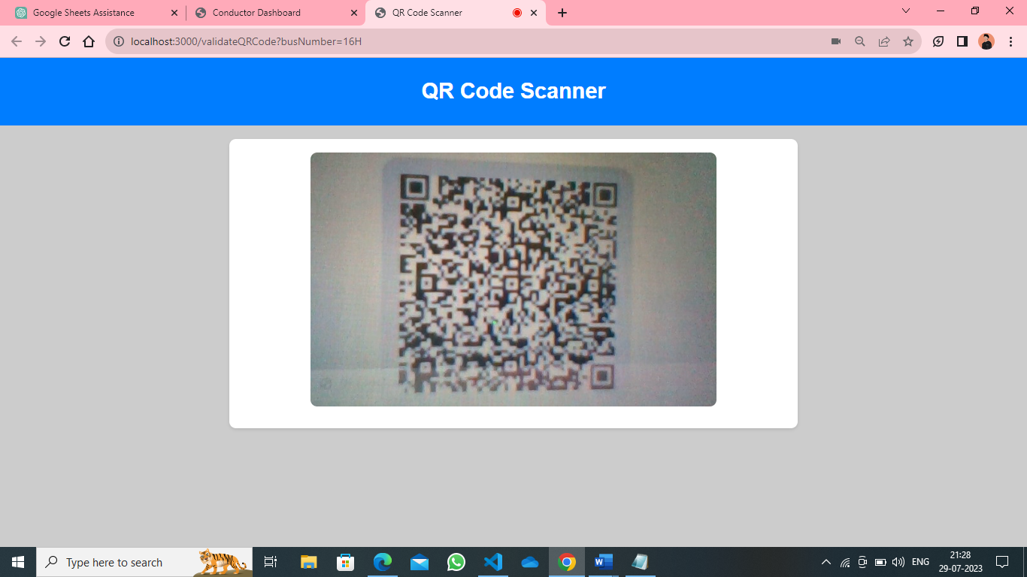

Fig 5.8 : QR Code validation page

The “QR Code validation page” Automatically opens the QR Code scanner and scans the QR Code. When the QR Code is detected, the scanner will close and the details are displayed which are retrieved from the QR Code with a Validate Details button.

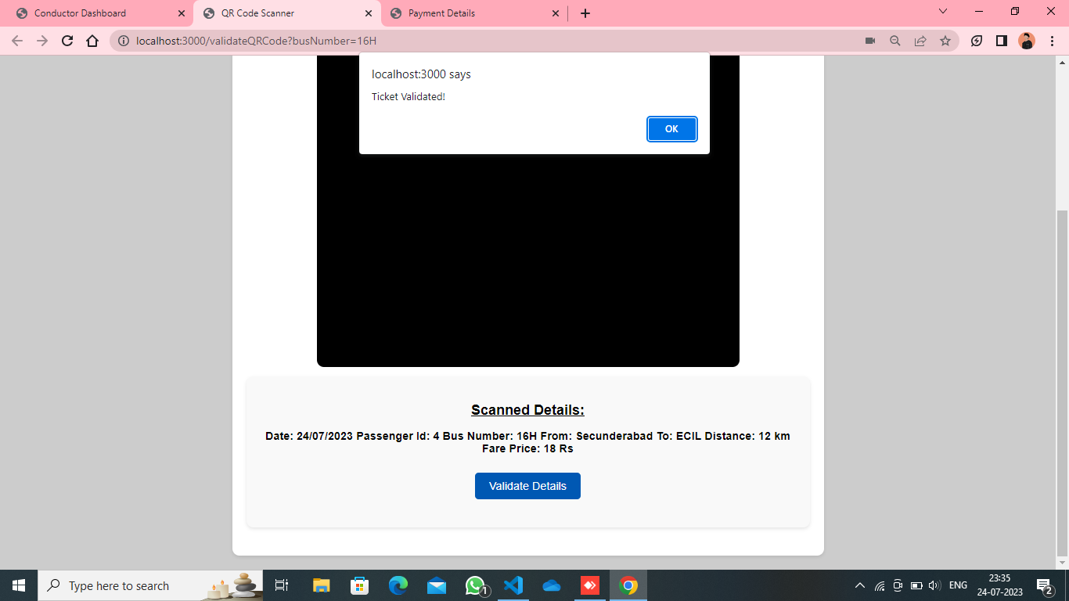

When the button is clicked it validates the details if the passenger’s bus number, bus operators bus number and passenger’s date, current date matches it prompts with the “Ticket Validated” message. If the details are not matched it prompts with “Invalid Ticket”.

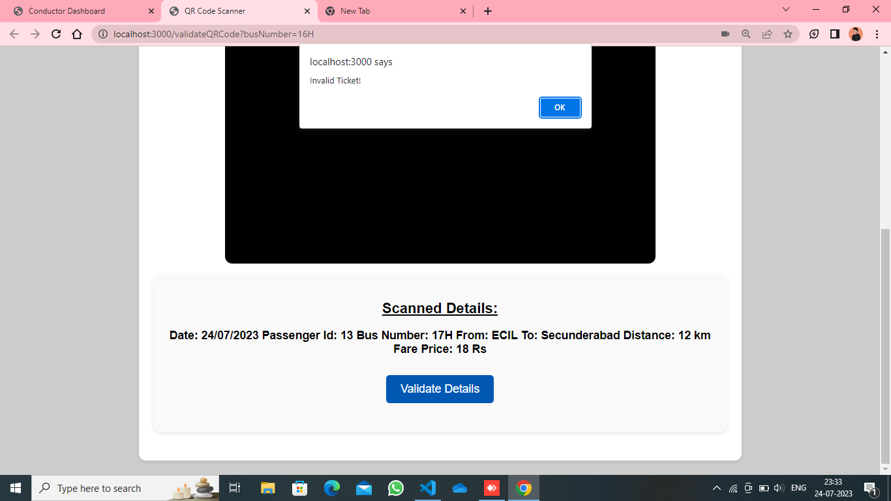

**6. FUTURE SCOPE**

* Integrating with GPS tracking for real-time bus tracking.
* Integrating with other transportation services for seamless multi-modal commuting.
* Integration with digital payment system and provides secure transactions.
* Mobile application development for enhanced user accessibility.
* Real-time updating of passenger count.

**7. CONCLUSION**

In conclusion, the Smart Bus Ticket Booking System is a user-friendly and efficient platform that streamlines the process of booking bus tickets online. It provides convenience to passengers by allowing them to easily search for available buses, and make secure payments. The system also benefits bus operators by enabling them to manage their fleet more effectively and reach a wider audience of customers.

With the proposed enhancements and future scope areas, the system has the potential to become even more valuable to both passengers and bus operators. As technology continues to advance, incorporating features like mobile applications, real-time traffic updates, and personalized offers can further improve the user experience and increase customer satisfaction.

Overall, the Smart Bus Ticket Booking System is a promising solution that simplifies bus ticket booking and contributes to a more seamless and enjoyable travel experience for all users.

**8. REFERENCES**

* [https://www.tsrtconline.in](https://www.tsrtconline.in/)
* <https://chat.openai.com/c/65bb7119-b0ed-4038-8e13-cd7ac253868e>
* <https://leafletjs.com/examples/quick-start/>
* <https://www.irjet.net/archives/V7/i6/IRJET-V7I6182.pdf&ved=2ahUKEwj-xsySi6mAAxXR-DgGHRU4BooQFnoECBAQAQ&usg=AOvVaw0rWeBgJoTATpBexxOgpy4B>